SquashRocs – Balls

Please feel free to use the balls here, just return them to the box after use.

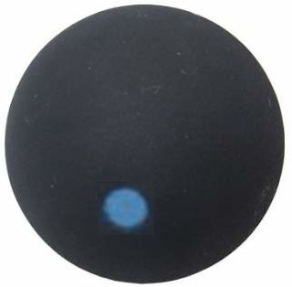

Blue Dot – FAST, BEGINNER. The most bouncy ball, good for beginners.

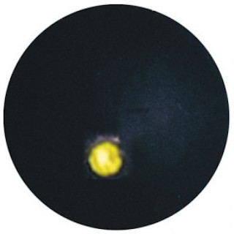

Single Yellow Dot – SLOW, ADVANCED. Less bouncy than the Blue Dot, good to switch to if the Blue Dot ball is too fast/easy for you.

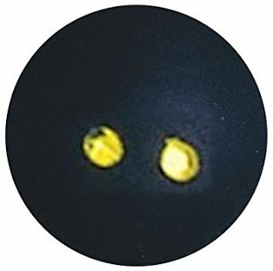

Double Yellow Dot – VERY SLOW, EXPERT. The ‘official’ ball, the least bouncy, to be played with once you are hitting the ball with some power.

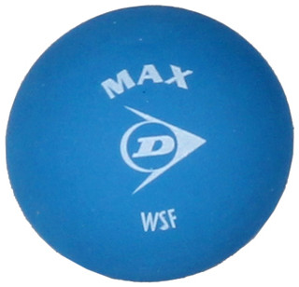

Blue Ball – CHILD. Quite bouncy, but larger and heavier, OK for beginners.

Note – for the ‘yellow dot’ balls, they need to be warmed up by hitting hard for a couple of minutes, before they get to their playing condition.

