# Google's Switzerland Office has its own Squash Court

It’s called "The T(in)"! And is part of the new recreation area, which also has a climbing wall and table tennis court.

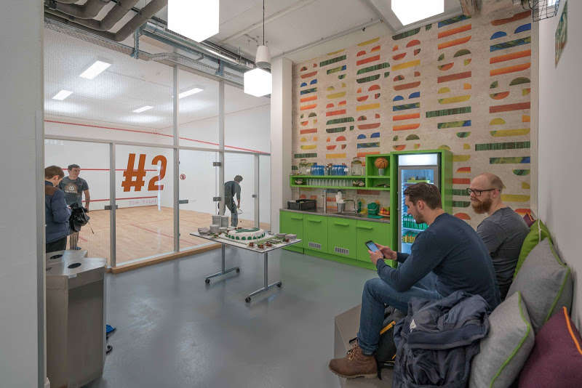 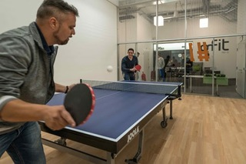

Hi Guys,

I'm headed to Zurich starting June 7th and am pumped to go. I've been a collegiate squash player here in the US and am really looking to keep up my squash game while I am in Zurich. I was wondering if people knew what the good places to play are and how expensive they are.

I am an incoming Visiting Student at ETH and my money is pretty short, so the cheapest options would be best. I've noticed the Grasshopper Club Zurich is the most famous option and I've heard Nicki Mueller trains there. But, if anybody is familiar with a deal for ETH students at one of these Squash clubs, I'd really appreciate it!!

Answer:

I play in Zug for 25 CHF per game for the court.

<http://www.sports-zugerland.ch/sports_zugerland/squash.html>

Squash is popular here so there are many places, and certainly closer to zurich. I know oberrieden, gattikon and thalwil also have courts.